**WLAN with static IP addressing and DHCP with MAC security and filters**

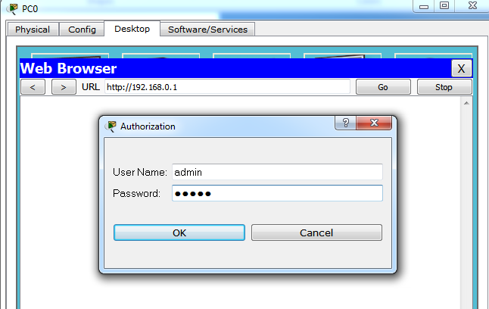

**Wireless Security**

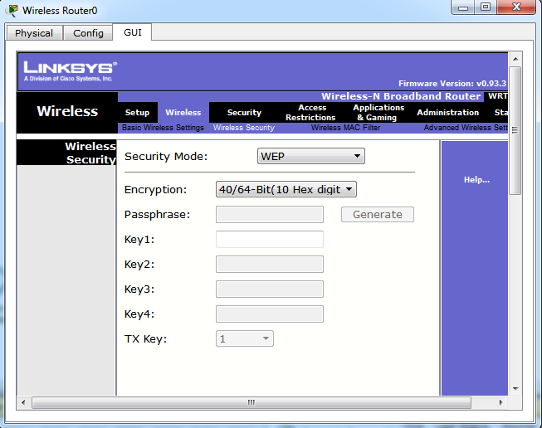

**Configuring Wireless router by using PC.**

**Through web browser of PC0 configure Wireless router**

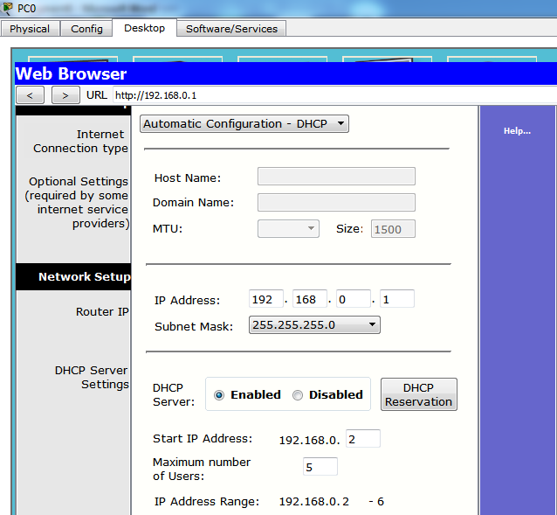

**MAC Filtering**

